A000-US-AR-Pipe-Human Head Effigy-Steatite-Mississippian-1200 CE

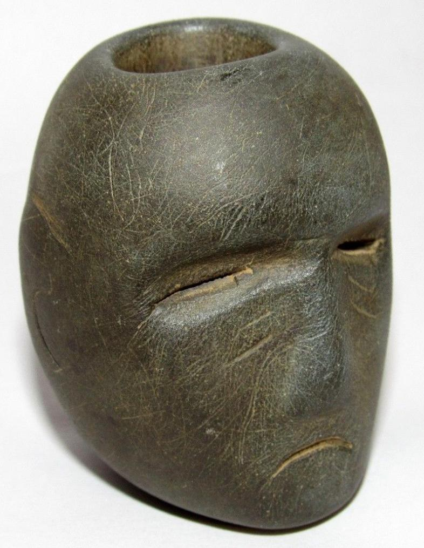 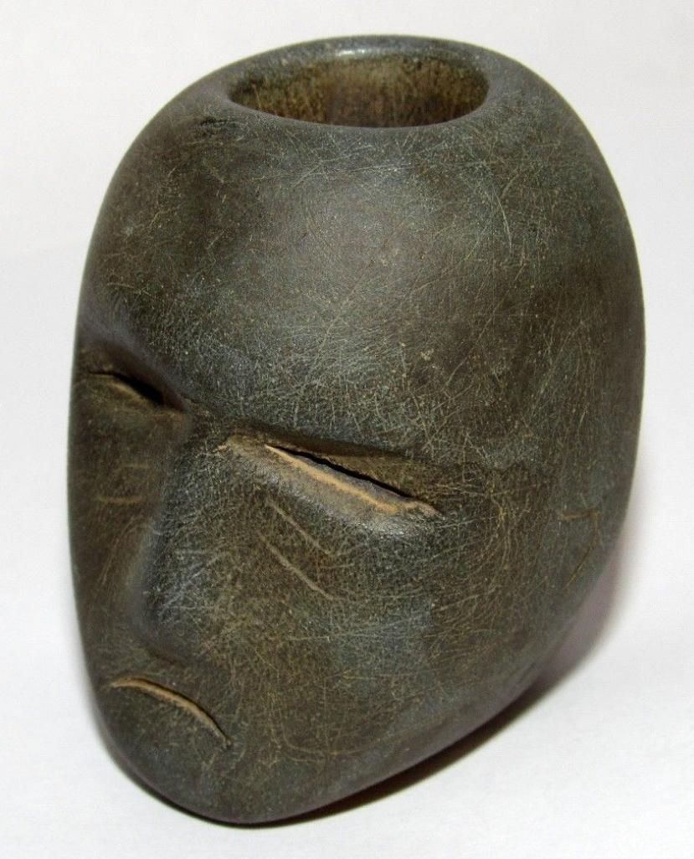 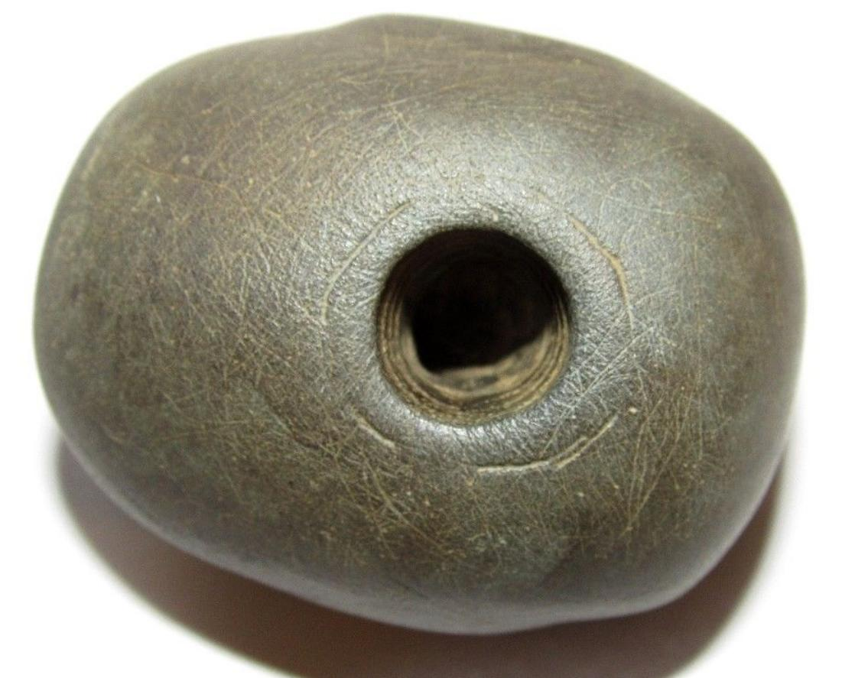 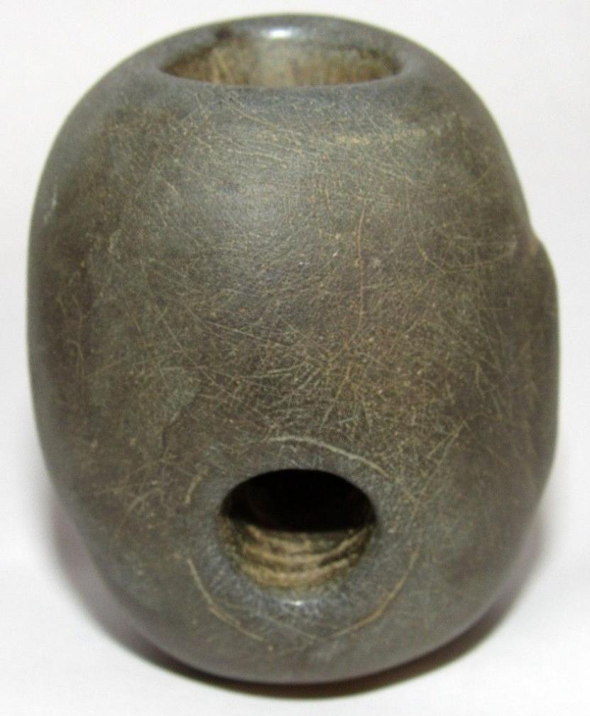 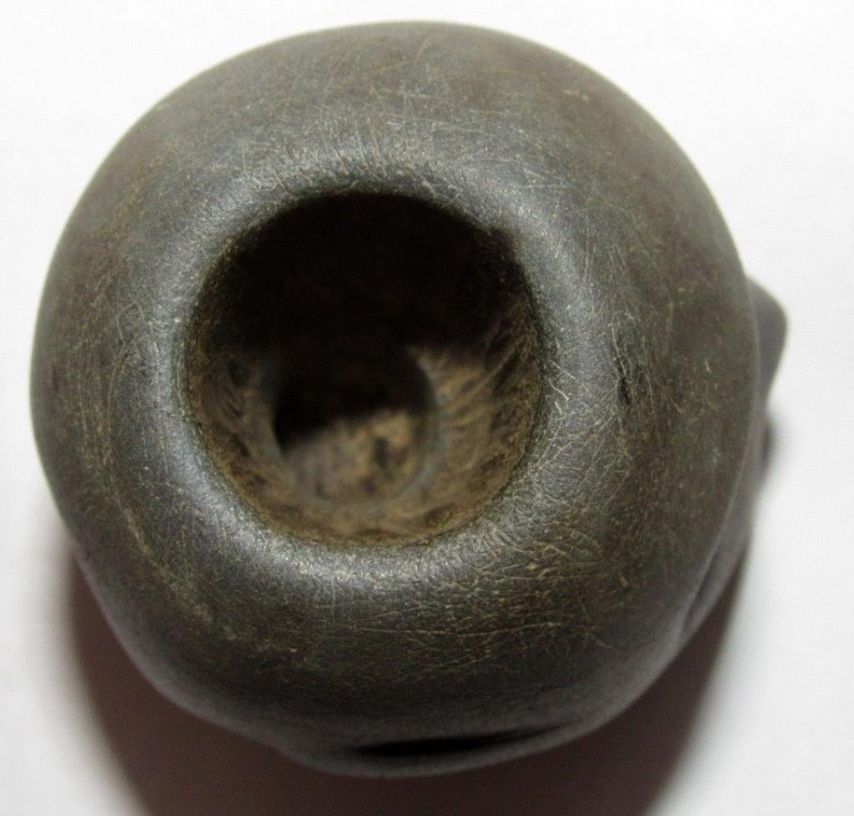

US-AR-Pipe-Human Head Effigy-Steatite-Mississippian-1200 CE

Case no.: 11

Accession Number:

Formal Label: US-AR-Pipe-Human Head Effigy-Steatite-Mississippian-1200 CE

**Display Description:**

Mississippian Human Head Effigy Pipe with nearly closed, sunken eyes, collapsed nasal septum, lipless mouth in a death grimace, expertly carved in steatite, from Arkansas, c 1200’s. The facial expression is comparable to the human heads on Mississippian pottery from Arkansas of the same era. The ritualism of these Human Head Effigy Pipes probably followed a similar pattern to that of the so-called “Calumet Pipe,” q.v.

Late Mississippian effigy heads are thought to represent deceased individuals. When they are accompanied by intricate tattooing they may be portraits of cherished ancestors, but when they are plain and only emphasize a death grimace such as this one they may represent revered, decapitated warriors.

**LC Classification:**

Date or Time Horizon:

Geographical Area: **northeast Arkansas and southeast Missouri**

**Map:**

**GPS coordinates:**

Cultural Affiliation:

Media:

Dimensions:

2 inches tall, 1 5/8 inches wide and 1 3/4 inches from back to front.

Weight:

Condition:

The pipe has an authentic patina and other than some minor surface wear, it is in excellent condition.

Provenance: These head effigies have provenances, where known, from northeast Arkansas and southeast Missouri and date 1200-1500 CE.

**Discussion:**

Human Head Effigy Vessels, Late Mississippian Culture, preserve details of head caps, hair designs, tattoo styles, iconographic representations of Mississippian symbols such as bird designs, falcon or weeping eye symbols and treatment of the heads including tattooing, keloids, hair styles including shaving designs, ear and nose piercing, dentition including filing and elimination of teeth and lip treatments, such as sewing or piercing.

Mills (1968) distinguishes two types of Human Head Effigy Vessels of the Late Mississippian Culture. Type A has appliqué facial features. Type A, Sub-type 1 has facial features in low relief, a long neck, ending in a flat base. Type A, Sub-type 2, has a short neck, a modeled face, which may be replicated on the opposing hemisphere, a restricted opening with a broadening lip and a base. Type B has a modeled face without any appliqué.

In his study, Mills found that Human Head Effigy Vessels centered on the AR Counties of Mississippi, Cross and Crittenden and the MO Counties of Scott, Mississippi and New Madrid: 44 of 63 examples and 61 of 63 were encompassed within a 100 and a 200-mile radius of this area respectively.

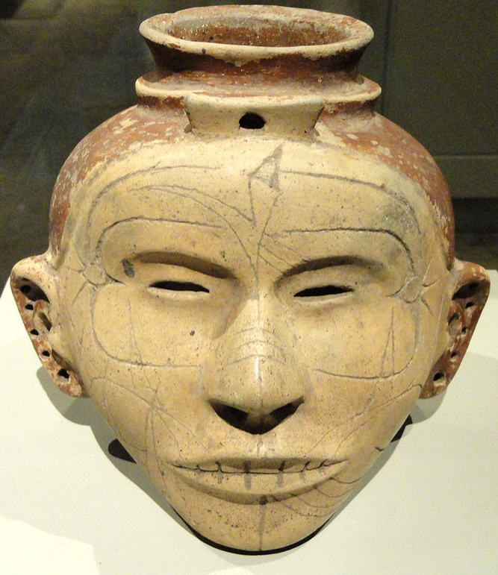

Human Head Effigy Vessel, Late Mississippian Culture, Type B, Chickasawba Site, MS County, AR, 1350-1550. Exhibit in the Nelson-Atkins Museum of Art, Kansas City, Missouri. [Creative Commons](https://en.wikipedia.org/wiki/en:Creative_Commons) [CC0 1.0 Universal Public Domain Dedication](https://creativecommons.org/publicdomain/zero/1.0/deed.en). After <https://upload.wikimedia.org/wikipedia/commons/thumb/b/b1/Human_Head_Effigy_Jar%2C_Late_Mississippian_Culture%2C_Chickasawba_Site%2C_Mississippi_County%2C_Arkansas>

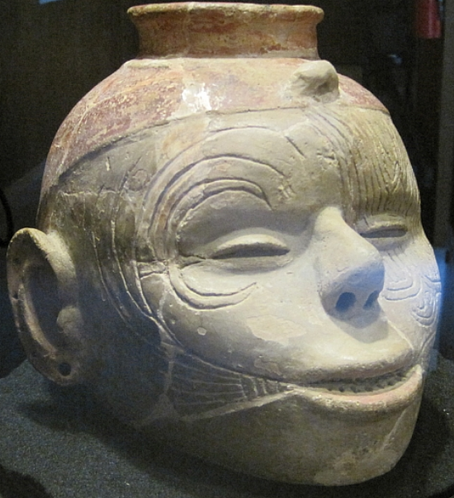

Human Head Effigy Vessel, Late Mississippian Culture, Type B. Hampson Museum State Park, Arkansas, Thomas R Machnitzki, 3 July 2010, Own work. <https://upload.wikimedia.org/wikipedia/commons/d/dc/Wilson_AR_Hampson_Museum_State_Park_19_human_head_effigy_vessel.jpg>

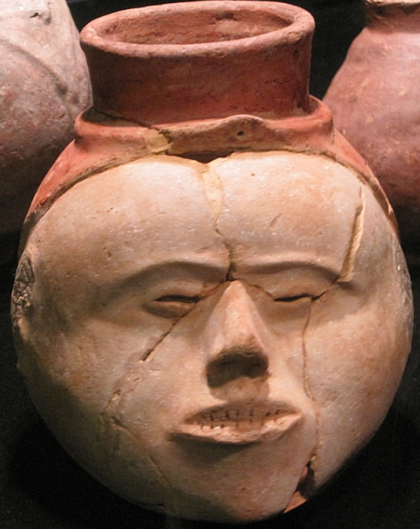

Human Head Effigy Vessel, Late Mississippian Culture, Type B. No Tattoos. Complete frontal dentition. Parkin Archeological State Park in Parkin, AR. Thomas R Machnitzki, 3 July 2010, Own work. By Thomas R Machnitzki - Own work, CC BY 3.0, https://commons.wikimedia.org/w/index.php?curid=11243791

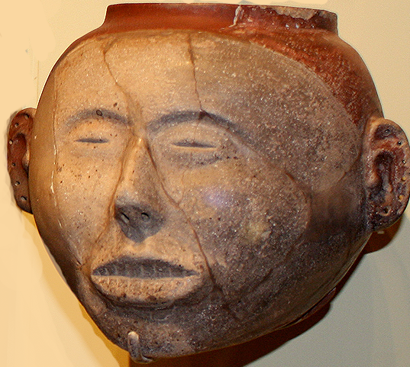

Human Head Effigy Vessel, Late Mississippian Culture, Type B. No Tattoos. Complete frontal dentition. from Rose Mound, Cross County, Arkansas. NMAI 17/3277. After https://upload.wikimedia.org/wikipedia/commons/e/ea/AR_ceramic_effigy_jar_1300_nmai.jpg

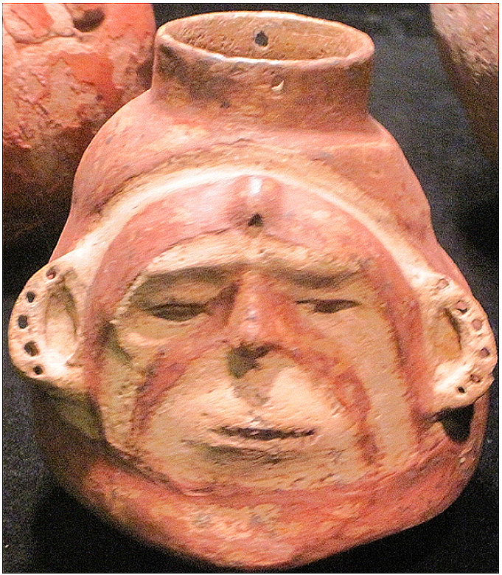

Human Head Effigy Vessel, Late Mississippian Culture, Type A. No Tattoos. No frontal dentition. Parkin Archeological State Park in Parkin, AR. By Thomas R Machnitzki - Own work, CC BY 3.0, <https://commons.wikimedia.org/w/index.php?curid=11243799>



Human Head Effigy Vessel, Late Mississippian Culture, Type B. No Tattoos. No frontal dentition. Parkin Archeological State Park in Parkin, AR. By Thomas R Machnitzki - Own work, CC BY 3.0,After <https://upload.wikimedia.org/wikipedia/commons/0/0e/Parkin_Archeological_State_Park_Parkin_AR_14.jpg>



Human Head Effigy Vessel, Late Mississippian Culture, Type A Auctions image. After https://www.liveauctioneers.com/news/wp-content/uploads/2014/05/2014_0523_morphy103_lead.jpg

Human Head Effigy Vessel, Late Mississippian Culture. Type-B with a delineation between shaved which is painted with red ochre and the face which is washed with kaolin slip.

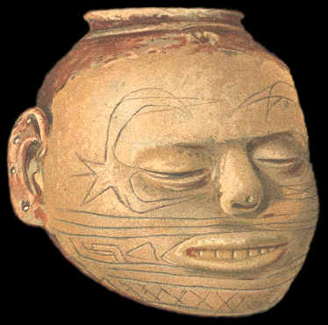

Human Head Effigy Vessel, Late Mississippian Culture. Type B accentuates the engraved lines, that represent tattooing and pierced ears, After Holmes 1903. From Pecan Point, AR. After

|  |  |
| --- | --- |
| |  | | --- | | **PHOTO CREDIT--BILL FECHT,**  **HUMAN HEAD EFFIGY VESSEL LATE MISSISSIPPIAN PERIOD NORTHEASTERN ARKANSAS OR SOUTHEASTERN MISSOURI** *GILCREASE INSTITUTE COLLECTION*  **This side view of another "classic" Type-B "head pot" shows the delineation line between the hair and face. The area where the hair would be is painted red with iron ore (hematite). The face also had a lighter color clay applied to the surface as a slip or wash. The facial features on this vessel are very accurate----an indication that it was made by a highly skilled artisan.** | |
| **Several names have been used for these clay human head effigies. They have been called, death head effigies, death's head vases, death masks, head vases, head vessels, head bottles, head jars and head pots. "Head pot" is the term that is often used to describe them but the written text uses a wide range of titles.** |
| **Late Mississippian human head effigies are rare. In 1968 Lawrence Mills reports that he has located and described 63 examples. Previous to his study, 59 examples had been reported.** |
| |  | | --- | | **DRAWING CREDIT, 20TH ANNUAL REPORT, BUREAU OF AMERICAN ETHNOLOGY, 1903, HOLMES**  **HUMAN HEAD EFFIGY VESSEL LATE MISSISSIPPIAN PERIOD PECAN POINT, ARKANSAS** *SMITHSONIAN INSTITUTION COLLECTION*  **This illustration, of an exceptionally well made Type-B "head pot," accentuates the engraved lines, that represent tattooing. The engraved lines is evidence that the Mississippian people probably used tattooing for body decoration. This vessel also has perforated ears, which is an indication that they may also have used body piercing for decoration.** | |
| **Head pots were made into many different shapes and designs. Mills divides them into two basic classifications, Type-A and Type-B. Type-A are vessel forms that have human facial features added to the surface. Type B are vessels that were made in the shape of a human head. Mills describes three sub-types within the Type-A group. Sub-type 1 have long necks, annular bases and facial features in low relief. Sub-type 2 have short necks, modeled faces and they may have faces on the front and back (Janus form). Sub-type 3 are globular in form, they have a small opening, a flaring lip and modeled base. Mills does not describe a sub-type for Type-B vessels.** |
| |  | | --- | | **PHOTO CREDIT--BILL FECHT, HUMAN HEAD EFFIGY VESSEL LATE MISSISSIPPIAN PERIOD ARKANSAS OR MISSOURI** *ST. LOUIS ACADEMY OF SCIENCE COLLECTION*  **This gray ware "head pot" has a longer neck which classifies it within the Type-A group of styles. There doesn't seem to be any paint on this vessel. Seven or eight holes were drilled for the pierced ears. There are also lines that delineate where the hair would be and very well done facial features.** | |
| **"Head pots" range in size from 3 inches (7.6 cm) to 9 1/4 inches (23.5 cm) high. The majority of them are between 6 inches (15.2 cm) and 8 inches (23 cm) high.** |
| |  | | --- | | **HUMAN HEAD EFFIGY VESSEL LATE MISSISSIPPIAN PERIOD ARKANSAS OR MISSOURI** *PRIVATE COLLECTION*  **The picture of this "head pot" was taken through a glass case where it lay with several discoidals (game stones). This is another "classic" example of a Type-B "head pot." Notice the red paint where the hair would be and the pierced ears and nose. The face shows expressive features of death. The eyes are closed and the lips are drawn up with the teeth exposed.** | |
| **Mills's survey of head vases lists the Arkansas Counties of Mississippi, Cross and Crittenden and the Missouri Counties of Scott, Mississippi and New Madrid as the central distribution area for "head pots." Forty four of the 63 examples he recorded came from within a hundred mile radius of this area. All of the "head pots" in his study, except for two examples, were found within a 200 mile radius.** |
| **ome "head pots' are decorated with engraved lines that represent tattooing. This is an indication that these people did practice tattooing as a form of body decoration. Some people have argued that the markings on the pots may be copies of tattoos that were on the deceased person in the grave they were buried with.** |
| |  | | --- | | **PHOTO CREDIT--BILL FECHT,**  **HUMAN HEAD EFFIGY VESSELS LATE MISSISSIPPIAN PERIOD NORTHEASTERN ARKANSAS OR SOUTHEASTERN MISSOURI** *GILCREASE INSTITUTE COLLECTION*  **This picture shows at least three different styles of "head pots." The second and third examples fall within the Type-A classification of vessel styles because they both have long decanter style necks. But the third example has such a stylized face that it may not be considered a "head pot" at all. The two painted examples on the end are "classic" Type-B vessels. They have "modeled heads" and no bases or bottle type necks. The first "head pot" in the row is a unique and rare style. James B. Griffin called it the "Garland variant" and links it to the late horizon in the lower Arkansas Valley. This vessel is made of dark ware, without any paint. The facial features are a simply designed but the main theme of the vessel are the concentric rings that emanate from the area around he eyes. This "head pot" may also have another face on the opposite site (Janus figure).** | |
| **There can be no doubt that some "head pots" were made to represent a visual expression of death. They have closed eyes, a sunken nose and parted lips with teeth showing. The artist may have had the portrait of a particular face in mind before making the clay vessel. This may have been the deceased person or possibly a trophy head from someone killed in battle.** |
| |  | | --- | | **PHOTO CREDIT--BILL FECHT,**  **HUMAN HEAD EFFIGY VESSELS LATE MISSISSIPPIAN PERIOD NORTHEASTERN ARKANSAS OR SOUTHEASTERN MISSOURI** *GILCREASE INSTITUTE COLLECTION*  **Several different styles of "head pots" can be seen in this picture. The two on the right are the same ones illustrated and described in the above picture. The third examples from the right is a "classic" Type-B "head pot" in which the entire head is realistically modeled. It is painted red where the hair would be. The face was also colored with a lighter pigmented wash of clay. The fourth vessel in this row was painted red all over. It appears to be a globular form of "head pot" within the Type-A classification.** | |
| **There is evidence of ear and nose piercing by the Mississippian people. Most "head pots" have several perforations on each ear and sometimes the nose is also drilled across the septum. These vessels may have been decorated with various materials, like feathers or other organic items, when they were buried.** |
| |  | | --- | |  | |

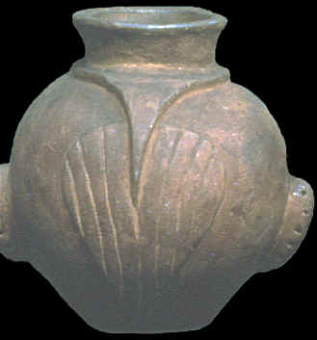  
Human Head Effigy Vessel, Late Mississippian Culture, Type B. from the AR/MO border and its pattern of a shaved hair style in the shape of a scallop shell that may be an emblem of tribal identity. From the St. Louis, MO, Academy of Science Collection, after W. Fecht photo.

**References**

Brose, D.S., Brown, J.A., Penney, D.W. and Bakker, D., 1985. *Ancient art of the American woodland Indians*. Harry N Abrams Inc.

Cherry, James F. 2009. *The Headpots of Northeast Arkansas and Southern Pemiscot County, Missouri*. Fayetteville: University of Arkansas Press.

Holmes, William H. 1903.  "Aboriginal Pottery of the Eastern United States," *20th Annual Report, Bureau of American Ethnol*ogy. Washington, DC: Smithsonian Institution, pp. 96-98.

Mills, Lawrence. 1968. "Mississippian Head Vases of Arkansas and Missouri," *The Missouri Archaeologis*t, 30: 1-83.

Moore, Clarence B. 1911. “Some Aboriginal Sites On Mississippi River,” *Journal of The Academy of Natural Sciences of Philadelphia*, 14: 401-476.

Townsend, Richard F. ed. 2004 *Hero, Hawk, and Open Hand: American Indian Art of the Ancient Midwest and South*. Chicago: The Art Institute of Chicago; Yale University Press.

Westbrook, Kent C. 1982. *Legacy in Clay: Prehistoric Ceramic Art of Arkansas*. Little Rock: Rose Publishing Co.